# **Low Carbon Blockchain Tech Stack - Installation Guide**

This document will ensure that all team members are running the same version of all software for the Low Carbon Blockchain Tech Stack. There will be multiple ways to get the tech stack identically installed across different environments. Some will be recommended and some are optional.

## **System Requirements**

Depending on the option selected: This installation guide contains a few different ways to set up the required tech stack in order to start hacking away!

**OS requirements**: Windows 10, Windows 11, Mac OS 10.15+, Linux (can also use Linux through VM)

**CPU requirements**:Intel or AMD chip that supports virtualization (Check to see if your CPU supports virtualization)

**Memory Requirements**: 8GB minimum, 16GB+ preferred

**HDD Requirements**: At least 75GB free space. SSD drive preferred, not required.

**Software Requirements:**

*Python 3.10+* for any Kubernetes networking script we may develop. Ensure python is on the environment path (Will be installed in this guide later)

## **Installing Python 3 and setting up the directory**

| TODO: add Mac Screenshots |
| --- |

This section is really platform agnostic, meaning it doesn't really matter which operating system you are running with. This is mainly to set up the environment in which we can develop things and create things to test along the way.

So first things first, you would want to install Python 3.10+ on your machine and ensure that it is in the path.

For Windows and Mac, I recommend getting python directly from the [python site](https://www.python.org/downloads/) with their installer. Ensure all settings about adding python to the path are checked.

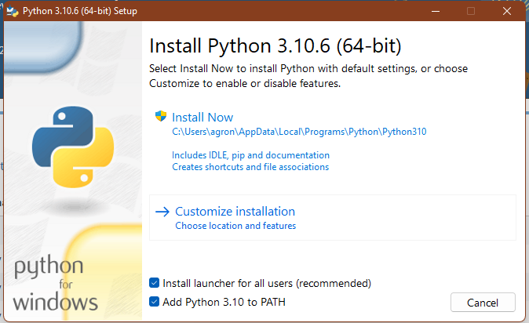

To ensure that you are using the correct version, open a terminal of your choice and run the following command: You may need to try python3 if python shows version 2 or if you are on mac.

| python --version |
| --- |

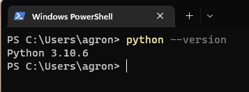

Now that python 3.10 is installed, navigate to a folder that you want to use for the project. We will eventually set up a git repo that we can push and pull from, however, for the time being, navigate to a folder you want to work in. I will make one called lcb-main in my Desktop. I will also create the python virtual environment that will allow us to constrain all needed python modules to just our project to avoid problems later.

| cd Desktop mkdir lcb-main cd lcb-main python -m venv env |
| --- |

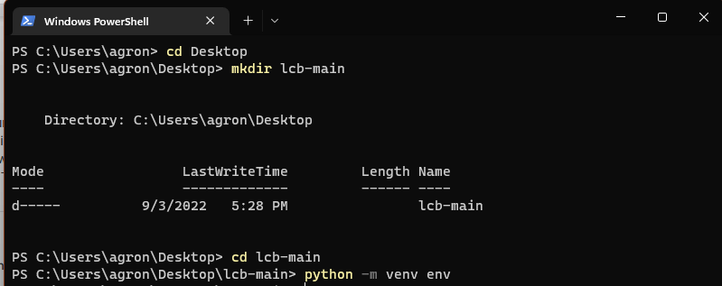

Now everytime you are working in the environment for this project, you will navigate to the folder and run the following in the terminal.

| .\env\Scripts\activate (on Windows) |
| --- |

| source env/bin/activate (on Mac or Linux) |
| --- |

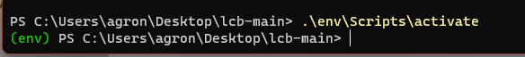

If you want to disconnect of the current environment you can either close the terminal and reopen or run the below command:

| deactivate |
| --- |

That will be all thats needed for getting python installed and setting up the environment for now.

## **Installing Docker and Kubernetes (Recommended Way) Windows/Mac - Docker Desktop**

Kubernetes and Docker will allow us to spin up containers that have an orchestrator(Kubernetes). There is really not much that we need else to begin our journey with this long project so these two are the best to start with.

### Windows

Now that we’ve ensured that our machine can run both of the needed software. Let’s actually install them. I will showcase Windows first, and then show Mac.

First, download and run through the install of Docker Desktop from [Docker](https://www.docker.com/products/docker-desktop/) --- ([DIRECT DOWNLOAD](https://desktop.docker.com/win/main/amd64/Docker%20Desktop%20Installer.exe?utm_source=docker&utm_medium=webreferral&utm_campaign=dd-smartbutton&utm_location=header))

|  |  |
| --- | --- |

You might need to restart your computer so once you do that, you should be able to open Docker and see the following home screen. There are not many steps after this, we just need to ensure that Docker can enable Kubernetes now.

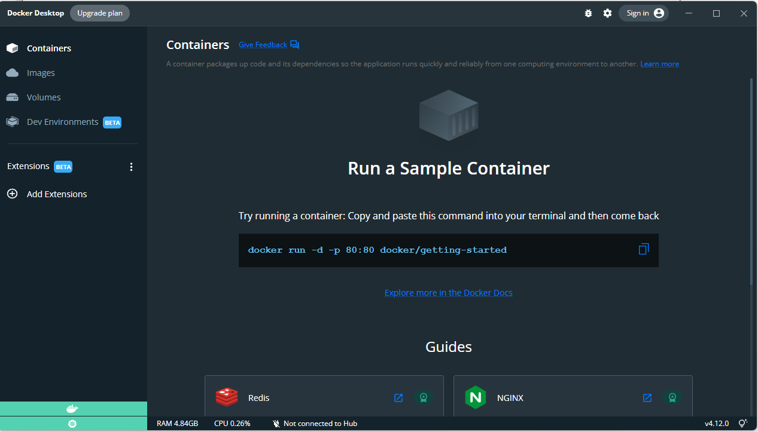

Click the settings gear icon in the top right next to the account settings and navigate to the Kubernetes tab and ensure you have Kubernetes enabled. You may have to wait a few minutes for Docker to apply your change and save settings.

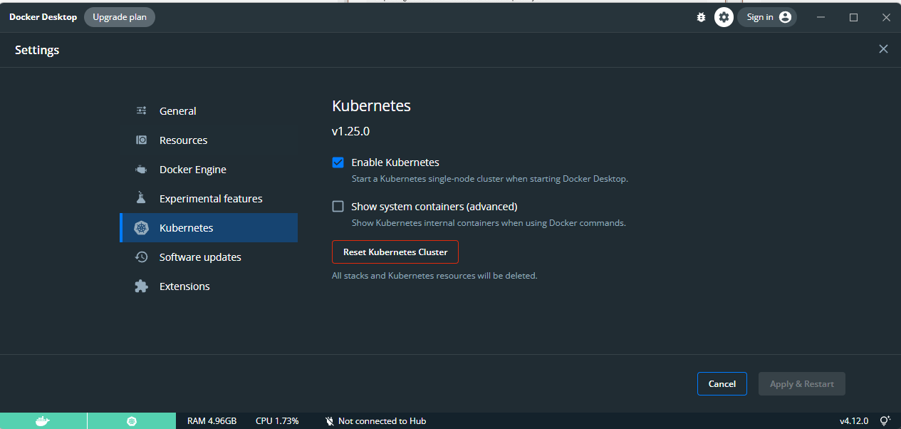

Once you have Kubernetes enabled, ensure the two colors in the bottom left are both green, if they are, then you are all set with installing on Windows.

Lastly, double check kubectl (Kubernetes control porgram) is installed by opening your windows terminal and running the following command. You should not see any errors that say the terminal could not find kubectl. You should see an operable version number.

| kubectl version |
| --- |

### 

### Mac

| TODO: will need to generate Mac Screenshots and notes |
| --- |

## **Installing Docker and Kubernetes (Not Recommended but works on any platform)**

| TODO: add process of Ubuntu VM and then installing kubernetes like that. May drop this, but will have the others try the above method first. |
| --- |

## **Miscellaneous**

### **System Requirements - Check for CPU Virtualization**

If you are on a Mac, you can skip this part. The intel processors on a Mac should automatically support virtualization in most cases.

As for Windows or Linux hosts, do the following:

On Windows, open up your task manager. You can do this by hitting the Windows Key+R at the same time and typing in taskmgr.exe, or by searching for task manager in the windows spotlight search bar.

|  |  |
| --- | --- |

Once the task manager is opened, you will want to navigate to the Performance Tab. (You may need to expand the task manager before by clicking the “More Details” Button.

After viewing the performance tab, check for the details under the CPU tab and ensure that the Virtualization option is Enabled. If it is disabled, you may need to enable it in your BIOS. I will not be explaining how to do that here as each motherboard manufacturer is different, however, if you look up your machines virtualization settings online, you will find plenty of guides to enable it.

You can still continue if it is disabled, however, this may cause technical and performance issues later on.